**DAILY ONLINE ACTIVITIES SUMMARY**

|  |  |  |  |  |  |  |  |
| --- | --- | --- | --- | --- | --- | --- | --- |
| **Date:** | **31/05/20** | | | | **Name:** | **Namratha C** | |
| **Sem & Sec** | **8th sem, A sec** | | | | **USN:** | **4AL16CS056** | |
| **Online Test Summary** | | | | | | | |
| **Subject** | | **IoT** | | | | | |
| **Max. Marks** | | **20** | | **Score** | | **19** | |
| **Certification Course Summary** | | | | | | | |
| **Course** | **Introduction to AWS codestar** | | | | | | |
| **Certificate Provider** | | | **Aws training and certification** | **Duration** | | | **10 mins** |
| **Coding Challenges** | | | | | | | |
| **Problem Statement: 1) Python program to find GCD of more than two (or array) numbers** | | | | | | | |
| **Status: Completed** | | | | | | | |
| **Uploaded the report in Github** | | | | **Yes** | | | |
| **If yes Repository name** | | | | **CODES (Namrathasonu)** | | | |
| **Uploaded the report in slack** | | | | **Yes** | | | |

Online Test Details:

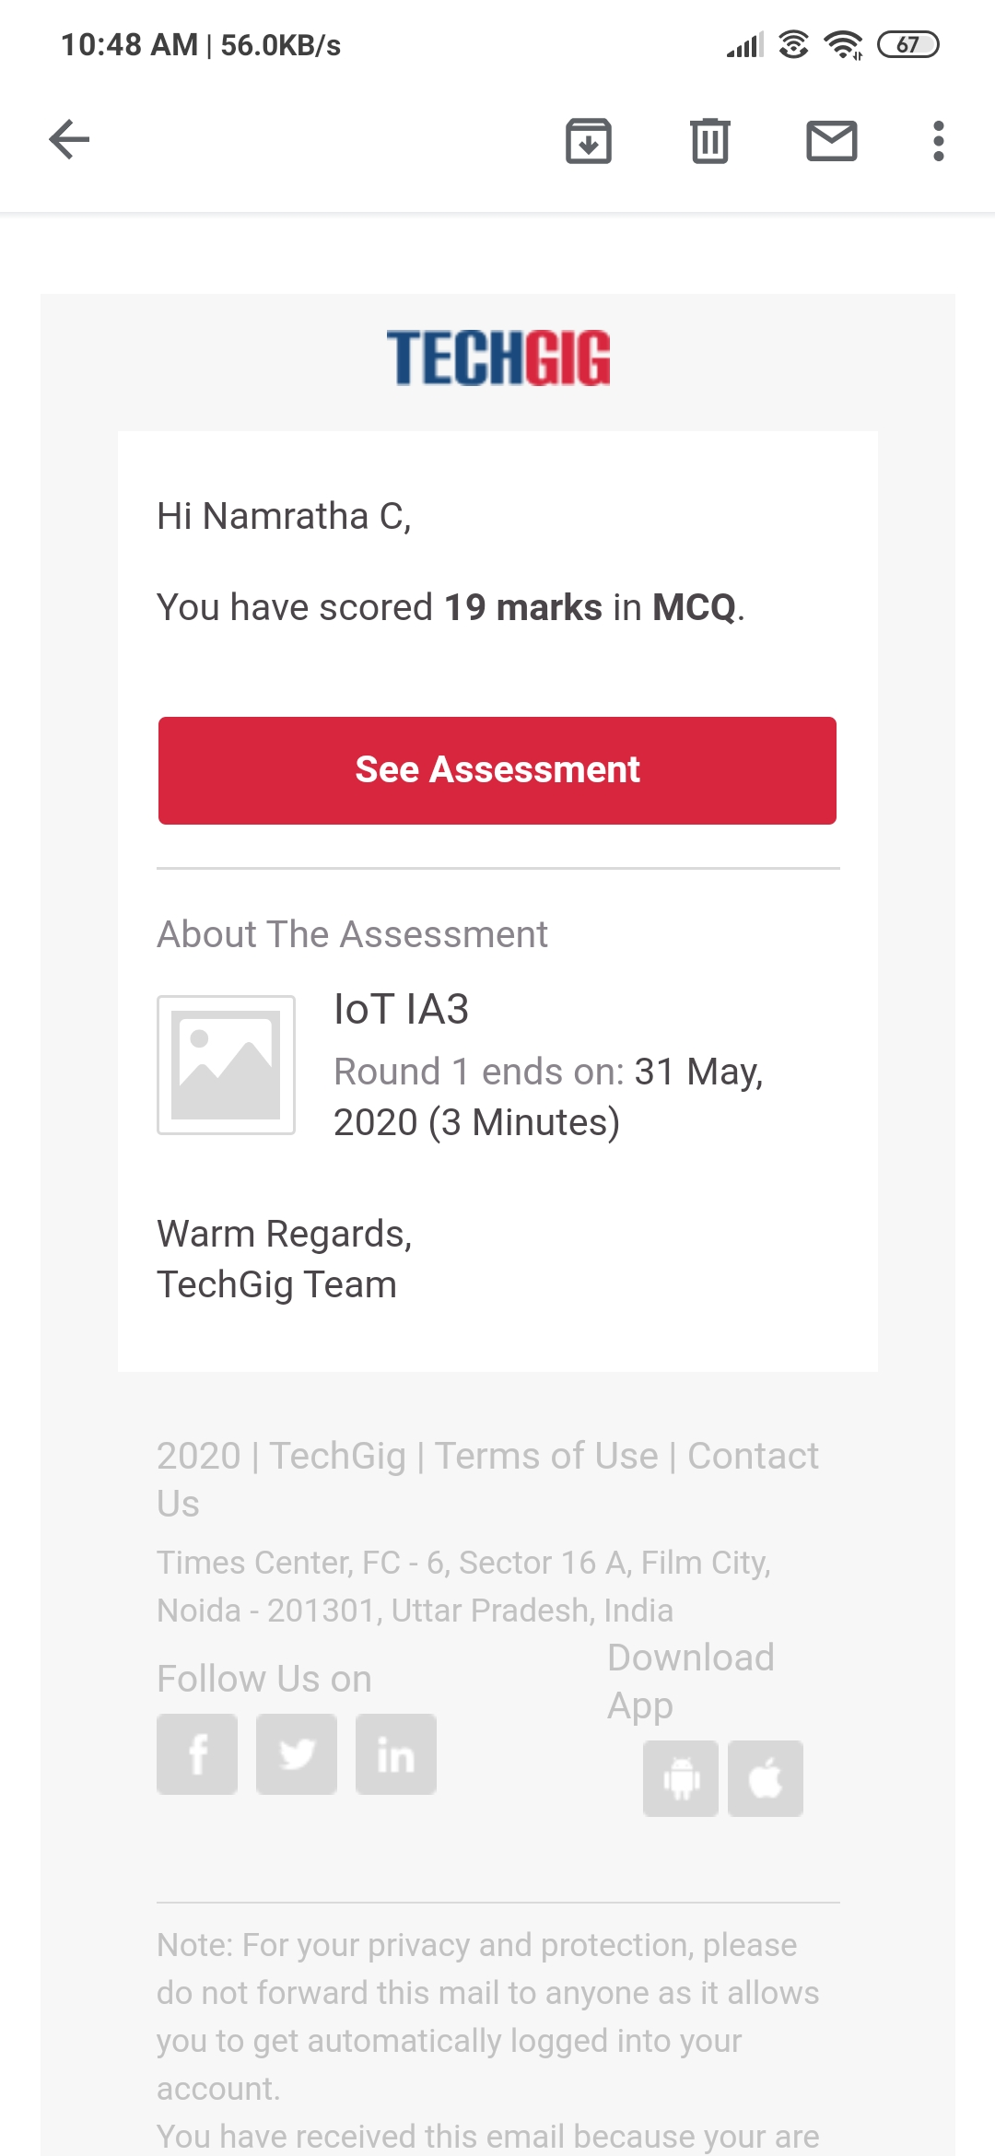

The test was on the subject Internet of Things.

Certification Course Details:

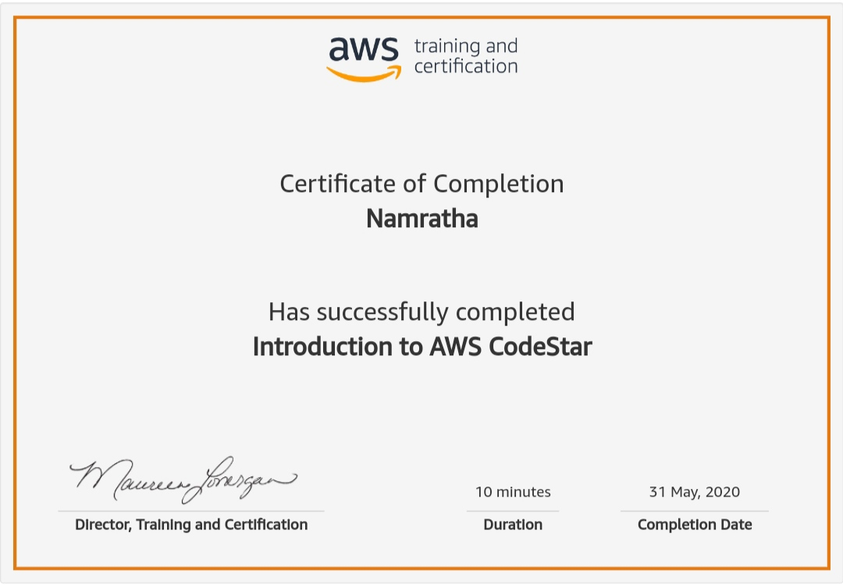

AWS CodeStar is a cloud-based service for creating, managing, and working with software development projects on AWS. You can quickly develop, build, and deploy applications on AWS with an AWS CodeStar project. An AWS CodeStar project creates and integrates AWS services for your project development toolchain.) .

Coding Challenges Details:

1)

def find_gcd(x, y):

while(y):

x, y = y, x % y

return x

l = [2, 4, 6, 8, 16]

num1=l[0]

num2=l[1]

gcd=find_gcd(num1,num2)

for i in range(2,len(l)):

gcd=find_gcd(gcd,l[i])

print(gcd)